Implement an iterator over a binary search tree (BST). Your iterator will be initialized with the root node of a BST.

Calling next() will return the next smallest number in the BST.

**Example:**

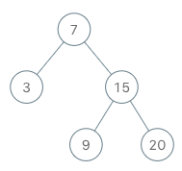

BSTIterator iterator = new BSTIterator(root);

iterator.next(); // return 3

iterator.next(); // return 7

iterator.hasNext(); // return true

iterator.next(); // return 9

iterator.hasNext(); // return true

iterator.next(); // return 15

iterator.hasNext(); // return true

iterator.next(); // return 20

iterator.hasNext(); // return false

**Note:**

* next() and hasNext() should run in average O(1) time and uses O(*h*) memory, where *h* is the height of the tree.
* You may assume that next() call will always be valid, that is, there will be at least a next smallest number in the BST when next() is called.